‘Open Library’ Website STP document

Version: 3cb7cfe

Anan Husein

**stp**

## Table of Contents

1. INTRODUCTION 3
2. SCOPE 4
3. QUALITY OBJECTIVES 4
   1. Primary Objectives 4
   2. Secondary Objectives 4
4. TEST APPROACH 5
5. ROLES AND RESPONSIBILITIES 5
6. ENTRY AND EXIT CRITERIA 6
   1. Entry Criteria 6
   2. Exit Criteria 6
7. SUSPENSION AND RESUMPTION 7
   1. Suspension criteria 7
   2. Resumption requirements 7
   3. Risks Management 7
8. TEST STRATEGY 9
   1. QA role in test process 9
   2. Bug life cycle: 11
   3. Testing types 12
   4. Bug Severity and Priority Definition 12

Severity List 12

Priority List 13

1. RESOURCE AND ENVIRONMENT NEEDS 13
   1. Testing Tools 13
   2. Test Environment 14
2. TEST SCHEDULE 14

APPROVALS 15

TERMS/ACRONYMS 15

**Test Plan**

## Project “Open Library”

Document Revision History

|  |  |  |  |  |  |
| --- | --- | --- | --- | --- | --- |
| Date | Version | Description | Author | Reviewer | Approver |
| 10/07/24 | 1.0 | Test plan was created | Anan |  |  |

## INTRODUCTION

The Open Library website is a digital platform created with the mission to provide free and universal access to all knowledge. An initiative of the Internet Archive. This ambitious project offers millions of books, including many rare and out-of-print titles, available for reading and borrowing. With a user-friendly interface, it allows users to browse, search, and read a vast collection of books online. Additionally, it allows users to contribute by adding new books, correcting information, and enhancing the database, making it a comprehensive and constantly evolving resource for readers, researchers, and book lovers worldwide.

## SCOPE

The document mainly targets the functional testing

* + - UI

## QUALITY OBJECTIVES

## Primary Objectives

A primary objective of testing is to: assure that the system meets the full requirements, including quality requirements (functional and non-functional requirements) and fit metrics for each quality requirement and satisfies the use case scenarios and maintain the quality of the product. At the end of the project development cycle, the user should find that the project has met or exceeded all of their expectations as detailed in the requirements.

Any changes, additions, or deletions to the requirements document, Functional Specification, or Design Specification will be documented and tested at the highest level of quality allowed within the remaining time of the project and within the ability of the test team.

## Secondary Objectives

The secondary objectives of testing will be to: identify and expose all issues and associated risks, communicate all known issues to the project team, and ensure that all issues are addressed in an appropriate matter before release. As an objective, this requires careful and methodical testing of the application to first ensure all areas of the system are scrutinized and, consequently, all issues (bugs) found are dealt with appropriately.

## TEST APPROACH

The approach, that used, is Analytical therefore, in accordance to requirements-based strategy, where an analysis of the requirements specification forms the basis for planning, estimating and designing tests. Test cases will be created during exploratory testing.

## ROLES AND RESPONSIBILITIES

|  |  |  |
| --- | --- | --- |
| Role | Staff Member | Responsibilities |
| Project Manager | Tzahi Anidgar | 1. Acts as a primary contact for development and QA team. 2. Responsible for Project schedule and the overall   success of the project. |
| QA Lead | Yair Amon | 1. Participation in the project plan creation/update process. 2.Planning and organization of test process for the release. 3.Coordinate with QA analysts/engineers on any issues/problems encountered during testing.  4.Report progress on work assignments to the PM (Project Manager ). |
| QA | Anan Husein  Tester #  Tester #  Tester #  Tester # | 1. Understand requirements 2. Writing and executing Test cases 3. Preparing RTM** 4. Reviewing Test cases, RTM 5. Defect reporting and tracking 6. Retesting and regression testing 7. Bug Review meeting 8. Preparation of Test Data 9. Coordinate with QA Lead for any issues or problems encountered during test preparation/execution/defect handling. |

## ENTRY AND EXIT CRITERIA

## Entry Criteria

* All test hardware platforms must have been successfully installed, configured, and functioning properly.
* All the necessary documentation, design, and requirements information should be available that will allow testers to operate the system and judge the correct behavior.
* All the standard software tools including the testing tools must have been successfully installed and functioning properly.
* Proper test data is available.
* The test environment such as lab, hardware, software, and system administration support should be ready.
* QA resources have completely understood the requirements
* QA resources have sound knowledge of functionality
* Reviewed test scenarios, test cases and RTM

## Exit Criteria

* 90 % coverage of the test cases .
* No high priority or severe bugs are left outstanding.
* All high-risk areas have been fully tested, with only minor residual risks left outstanding.
* Cost – when the budget has been spent.
* The schedule has been achieved

## SUSPENSION CRITERIA AND RESUMPTION REQUIREMENTS

## Suspension criteria

* The build contains many serious defects which seriously or limit testing progress.
* Significant change in requirements suggested by client
* Software/Hardware problems
* Assigned resources are not available when needed by the test team.
* Problem with HR. (tester quit the job or got sick)

## Resumption criteria

* Resumption will only occur when the problem(s) that caused the suspension have been resolved.

## Risks management

|  |  |  |  |
| --- | --- | --- | --- |
| Risk | Severity | Likelihood | Handling |
| Client asks for changes in the program | 5 | 3 | Demanding more money and time.  Or delaying the change for later version (if possible) |
| Expert tester out for vacation for 2 weeks | 4 | 1 | Extend the completion date (if possible)  Or ask the QA lead for another tester at the same level from other team |
| Inexperienced developer | 4 | 2 | The developer will be supervised by another experienced developer |

# TEST STRATEGY

## QA role in test process

* Understanding Requirements:
  + Requirement specifications will be sent by client.
  + Understanding of requirements will be done by QA.
* Preparing Test Cases:

QA will be preparing test cases based on the exploratory testing. This will cover all scenarios for requirements.

* Preparing Test Matrix:

QA will be preparing the test matrix which maps test cases to respective requirement. This will ensure the coverage for requirements.

* Reviewing test cases and matrix:
  + Peer review will be conducted for test cases and test matrix by QA Lead
  + Any comments or suggestions on test cases and test coverage will be

provided by reviewer respective Author of Test Case and Test Matrix

* + Suggestions or improvements will be re-worked by author and will be send for approval
  + Re-worked improvements will be reviewed and approved by reviewer
* Executing Test Cases:
  + Test cases will be executed by respective QA on client's development/test site based on designed scenarios, test cases and Test data.
  + Test result (Actual Result, Pass/Fail) will be updated in test case document Defect

-Logging and Reporting:

QA will be logging the defect/bugs in Word document, found during execution of test cases. After this, QA will inform respective developer about the defect/bugs.

* Retesting and Regression Testing:

Retesting for fixed bugs will be done by respective QA once it is resolved by respective developer and bug/defect status will be updated accordingly. In certain cases, regression testing will be done if required.

* Deployment/Delivery:
  + Once all bugs/defect reported after complete testing is fixed and no other bugs are found, report will be deployed to client’s test site by PM.
  + Once round of testing will be done by QA on client’s test site if required, a report will be delivered along with sample output by email to respective lead and Report group.
  + QA will be submitting the filled hard copy of delivery slip to respective developer.

## Bug life cycle:

All the issues found while testing will be logged into Excel document Bug life cycle for this project is as follows: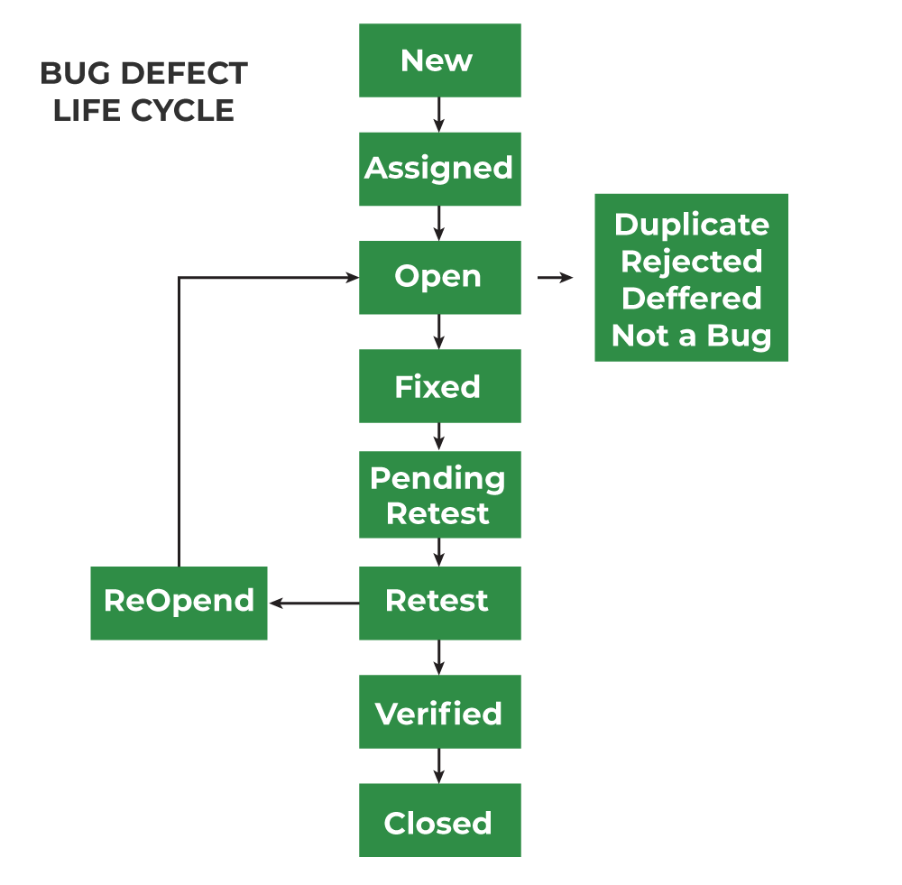

## Bug Severity and Priority Definition

Bug Severity and Priority fields are both very important for categorizing bugs and prioritizing if and when the bugs will be fixed. The bug Severity and Priority levels will be defined as outlined in the following tables below. Testing will assign a severity level to all bugs. The Test Lead will be responsible to see that a correct severity level is assigned to each bug. The QA Lead, Development Lead and Project Manager will participate in bug review meetings to assign the priority of all currently active bugs. The QA Lead is responsible for setting up these meetings on a routine basis to address the current set of new and existing but unresolved bugs.

## Severity List

|  |  |  |
| --- | --- | --- |
| **Severity ID** | **Severity** | **Severity Description** |
| 1 | Showstopper | The module/product crashes or the bug causes non- recoverable conditions. System crashes, database or file corruption, or potential data loss, program  hangs requiring reboot, are all examples of a Sev. 1 bug. |
| 2 | Major | Major system component unusable due to failure or incorrect functionality. Sev. 2 bugs cause serious problems such as a lack of functionality, or insufficient or unclear error messages that can have a major impact to the user, prevents other areas of the app from being tested, etc. Sev. 2 bugs can have a  work around, but the work around is inconvenient or difficult. |
| 3 | Minor | Incorrect functionality of component or process. There is a  simple work around for the bug if it is Sev. 3. |
| 4 | Low | Documentation errors or signed off severity 3 bugs. |

## Priority List

|  |  |  |
| --- | --- | --- |
| **Priority** | **Priority Level** | **Priority Description** |
| 1 | Critical | This bug must be fixed immediately; the product cannot  Be delivered with this bug. |
| 2 | High | These are important problems that should be fixed as soon as possible. It would be an embarrassment to the company  if this bug hasn’t been fixed. |
| 3 | Medium | The problem should be fixed within the time available. If  the bug does not delay delivering date, then fix it. |
| 4 | Low | It is not important (at this time) if these bugs aren't addressed. Fix these bugs after all other bugs have been fixed. |

## RESOURCE AND ENVIRONMENT NEEDS

## Testing Tools

|  |  |
| --- | --- |
| Process | Tool |
| Test case creation | Microsoft Excel |
| Test case tracking | Microsoft Word |
| Test case execution | PyCharm--Selenium |
| Test case management | Microsoft Excel |
| Defect management | Microsoft Excel |
| Test reporting | Microsoft Word |

## Test Environment

* Support level:
  + Lenovo laptop, Windows 11 Version 23H2
  + Chrome Browser v.126.0.6478.127

## TEST SCHEDULE

|  |  |  |  |  |
| --- | --- | --- | --- | --- |
| **Task Name** | **Start** | **Finish** | **Effort**  **(Days)** | **Comments** |
| Test Planning | 10/07/2024 | 10/07/2024 | 1 | Initial planning session to outline test strategy. |
| Review Requirements  Documents | 11/07/2024 | 11/07/2024 | 1 | Reviewing all requirements for the project. |
| Create test basis | 12/07/2024 | 12/07/2024 | 1 | Establishing the basis for test cases. |
| Staff and train new test resources | 13/07/2024 | 15/07/2024 | 3 | Training new team members on testing procedures. |
| First deploy to QA test  environment | 16/07/2024 | | 1 | Initial deployment of the application to the test environment. |
| Functional testing–  Iteration 1 | 17/07/2024 | 02/08/2024 | 16 | First round of functional testing on the application. |
| Iteration 2 deploy to QA  test environment | 03/08//2024 | 03/08/2024 | 1 | Second deployment with fixes and updates. |
| Functional testing–  Iteration 2 | 04/08/2024 | 14/08/2024 | 11 | Second round of functional testing on the updated build. |
| System testing | 15/08/2024 | 21/08/2024 | 7 | Comprehensive system testing for overall functionality. |
| Regression testing | 22/08/2024 | 28/08/2024 | 7 | Ensuring new changes do not affect existing functionality. |
| UAT | 29/08/2024 | 03/09/2024 | 6 | Client testing to verify the application meets their requirements. |
| Resolution of final defects  and final build testing | 04/09/2024 | 08/09/2024 | 5 | Fixing final defects and verifying the final build. |
| Deploy to Staging  environment | 09/09/2024 | 09/09/2024 | 1 | Deployment to the staging environment for final checks. |
| Performance testing | 10/09/2024 | 14/09/2024 | 5 | Testing the application's performance under various conditions. |
| Release to Production | 15/09/2024 | 15/09/2024 | 1 | Final release of the application to the production environment. |

# APPROVALS:

|  |  |  |
| --- | --- | --- |
|  | **Project Manager** | **QA Lead** |
| **Name** |  |  |
| **Signature** |  |  |

## TERMS/ACRONYMS

|  |  |
| --- | --- |
| **TERM/ACRONYM** | **DEFINITION** |
| UI | User interface |
| PM | Project manager |
| UAT | User acceptance testing |
| QA | Quality Assurance |
| RTM | Requirements Traceability Matrix |